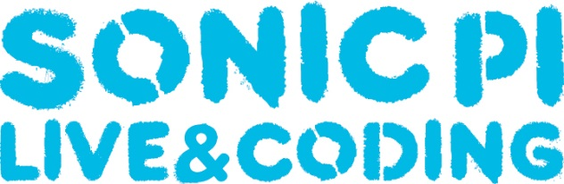

**Scheme of Work**

Sonic Pi is an application/program designed by live coder/developer Sam Aaron, originally for a Raspberry Pi computer. It is open source software developed in Super Collider with the objective of using code language to write music. Sonic Pi is a creative way for students to engage in electronic music composition through a fun and new method. Using Sonic Pi also introduces students to music technology, an upcoming and economically growing field, at an earlier level than degree or A-level.

|  |  |
| --- | --- |
| **Lesson 1:** Students will be exploring the Raspberry Pi/Sonic Pi independently and begin using basic terms to complete a familiar tune. | **Terms:** play, sleep, run |
| **Lesson 2:** After exploring Sonic Pi in the previous week, students will begin to use the terms: *loop do,* and *use_synth*. Students will continue with last week’s piece or create their own. | **Terms:** loop do, end, use_synth |
| **Lesson 3:** Students will engage with new terms such as: *use_sample* to create a drum loop within Sonic Pi, as well as develop an understanding of the origins of electronic samples. | **Terms:** sample:, sleep sample_duration |
| **Lesson 4:** Students will experiment with texture using the *thread* function within Sonic Pi. This will allow students to use multiple loops and instruments | **Terms:** in_thread do, end |
| **Lesson 5:** Students will engage with the idea of serial music and attempt to create their own using the *rrand* and *.choose* function | **Terms:** rrand, .choose |
| **Lesson 6:** Students will develop their current knowledge and begin work on their final composition using the briefs and assessment criteria provided as guidance. | **Terms:** |
| **Lesson 7:** Students will begin to use and explore *FX* functions within Sonic Pi and add them to their final compositions. | **Terms:** with_fx:, reverb, echo, rlpf |
| **Lesson 8:** Students will begin to manipulate sound through parameter functions such as *attack,* and *release.* | **Terms:** attack, release, sustain |
| **Lesson 9:** Students will discuss how to musically recreate sounds and begin work on their soundscape compositions using all the knowledge developed to date. | **Terms:** |
| **Lesson 10:** Students will finish their soundscapes and prepare for next week’s final performance. Deadline for final composition. Deadline for final composition and review | **Terms:** |
| **Lesson 11:** Student will use all of their knowledge developed throughout the term to participate in a class performance of a Sonic Pi Orchestra. | **Terms:** |